# KAHOOT QUIZ STEPS

Step 1) Select Exam URL from the below exam list.

* [SQL Server](https://play.kahoot.it/#/k/0a2ef54c-d57b-42f6-a5a3-32f925fd1102)
* [.NET Framework and C# 5.0](https://play.kahoot.it/#/k/ccb85ff7-6662-4479-8e88-03c27d12cdfd)
* [WPF](https://play.kahoot.it/#/k/da3696c6-274f-4962-a52b-e43b095b095c)
* [ADO.NET](https://play.kahoot.it/#/k/a4c36bb6-49e1-44e6-97d8-89e8f75b551f)
* [Linq and Entity Framework](https://play.kahoot.it/#/k/a102a187-cd75-4d77-9f4b-a87043451510)
* [ASP.NET](https://play.kahoot.it/#/k/e56c0cb3-90b1-4592-b4a9-6af2161b7657)
* [ASP.NET MVC](https://play.kahoot.it/#/k/1a46bead-51a8-4088-a096-ec934e08faca)
* [Jquery](https://play.kahoot.it/#/k/1ca5bdc1-2ffa-4eac-9493-af81d5d02570)
* [Angular JS](https://play.kahoot.it/#/k/6d10ab4a-2f48-4139-a583-3de46d4c18fe)
* [WEB API](https://play.kahoot.it/#/k/69217481-441d-49d4-a60d-0f79dd7a044b)
* [Overview of WCF](https://play.kahoot.it/#/k/e328023c-2e58-462f-9cb9-c40b5ad79470)
* [Devops with TFS](https://play.kahoot.it/#/k/1067a14c-7b55-4e18-9a64-6dacf356f39a)

Following will screen will appear

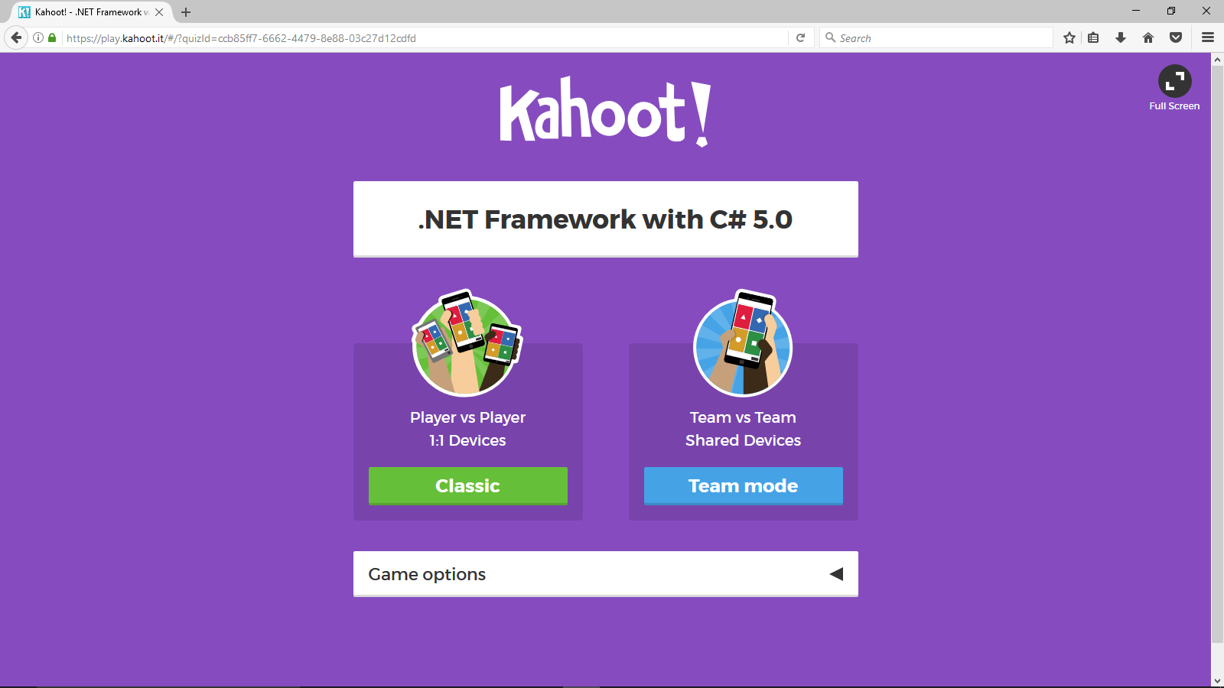

Step 2) Select Team Mode, after that game pin will appear.

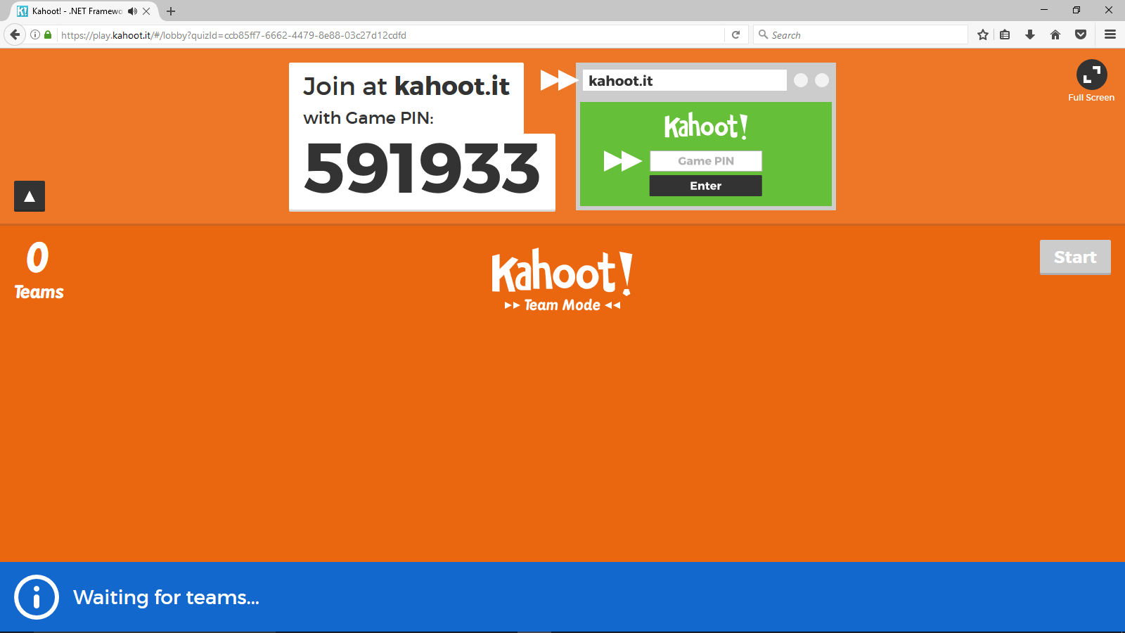

Step 3) Participant should login to <https://kahoot.it>

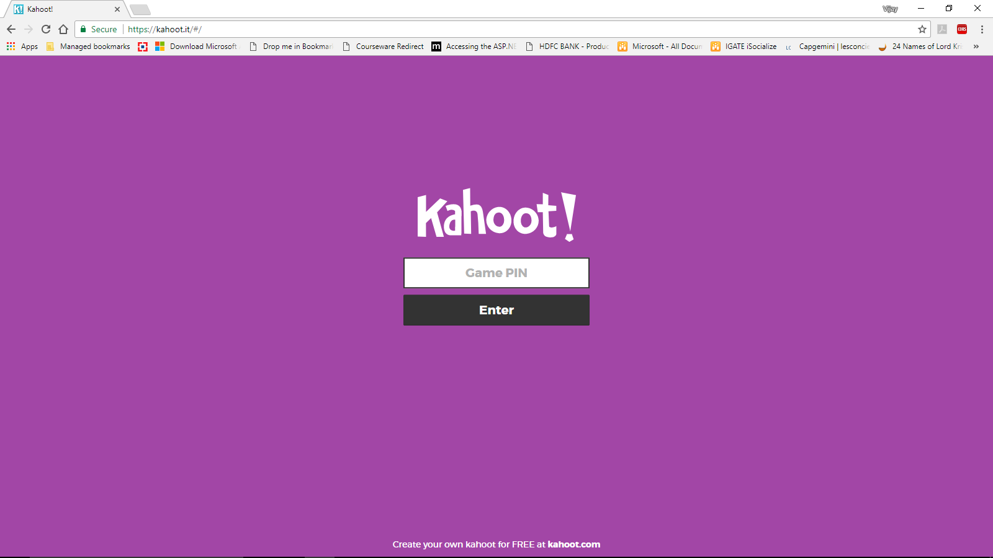

Step 4) Enter the game pin and give a name a to team.

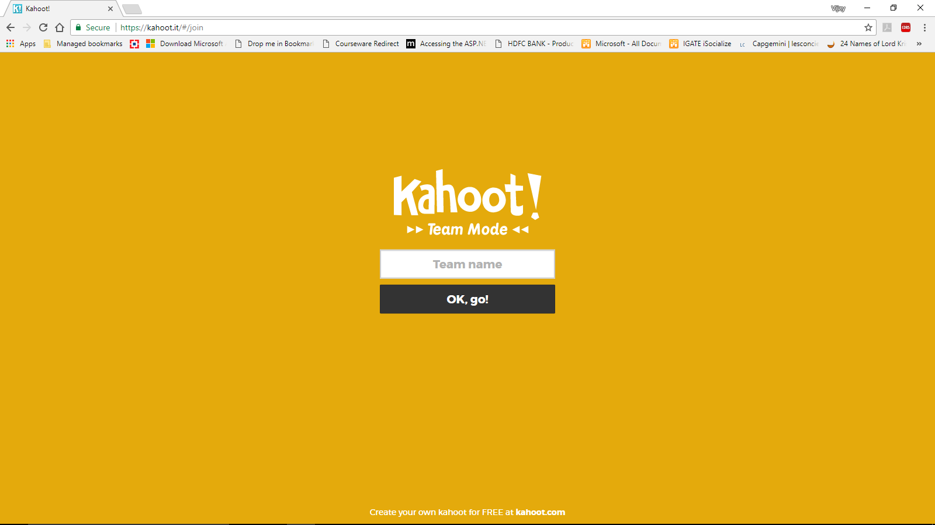

Step 5) Add team members name. Click on Ready to Join

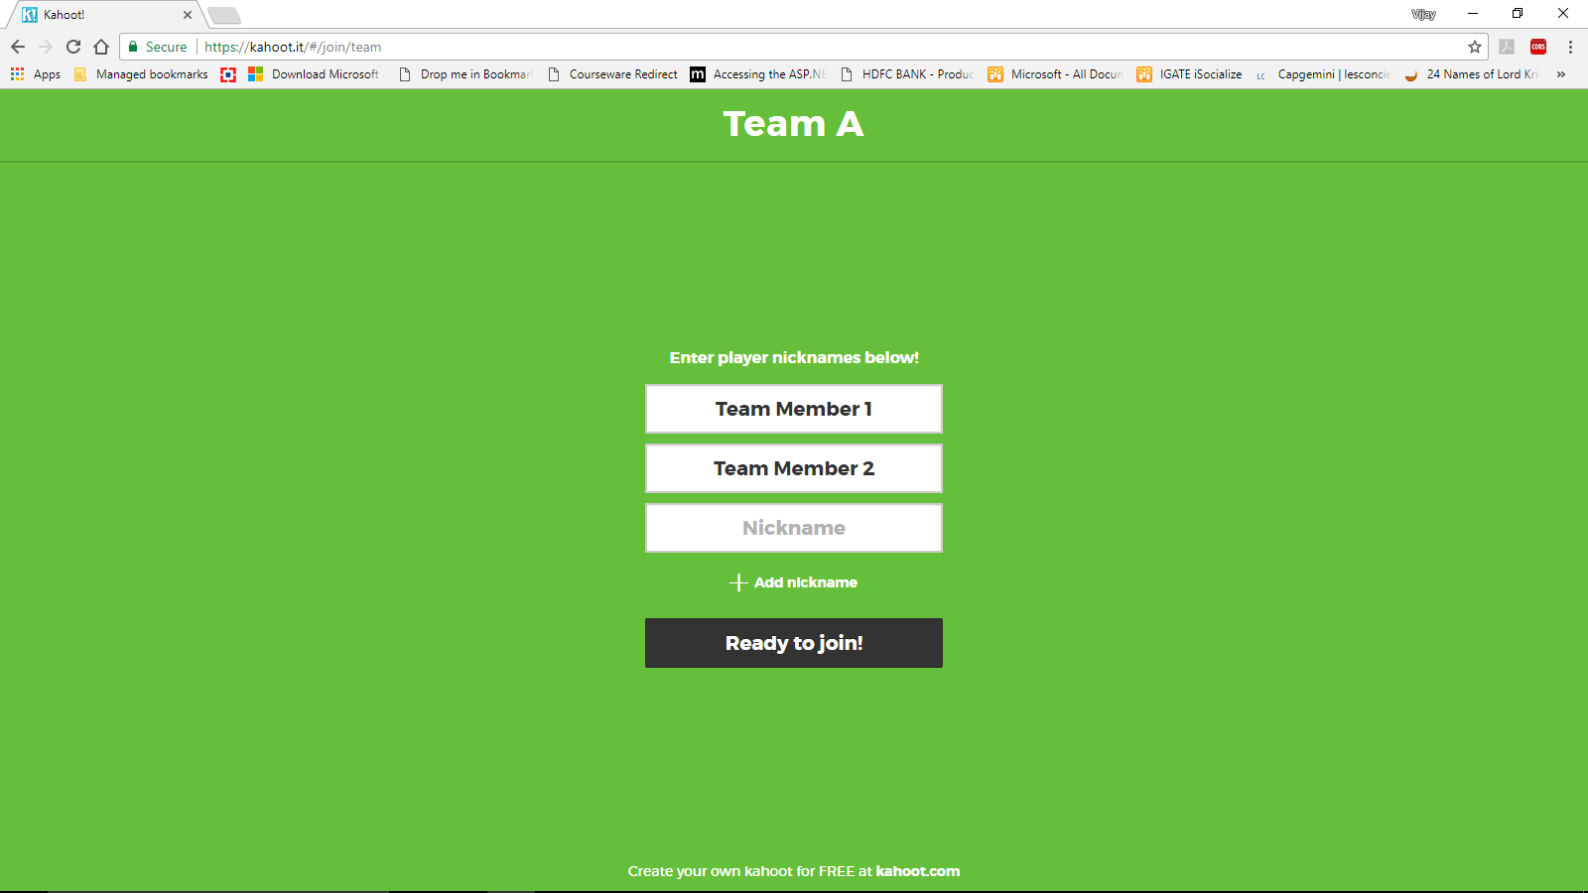

Step 6) Start the quiz by clicking on the Start button.

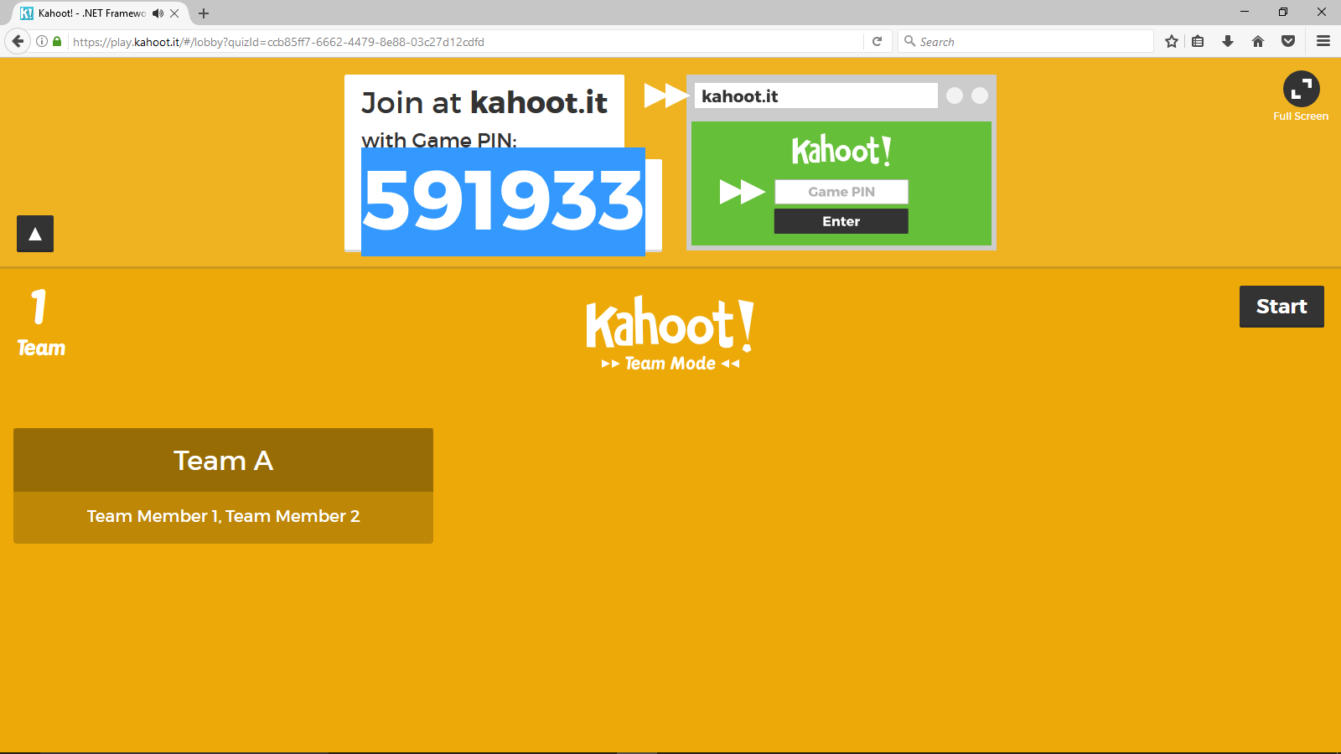

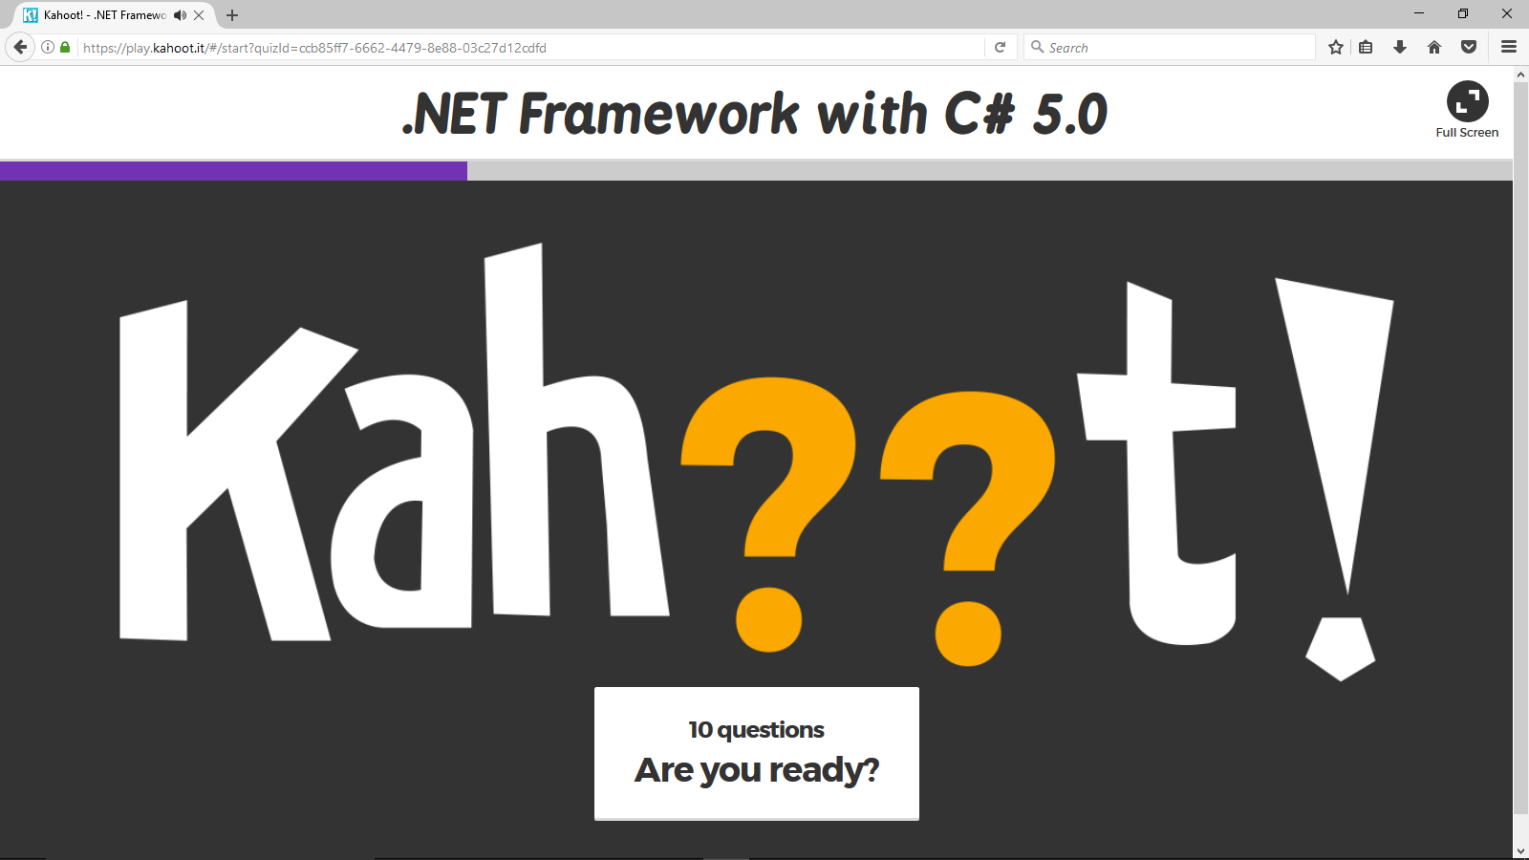

Step 7) Questions will be displayed on the screen, Team will get 5 Seconds to discuss and then 20 seconds to answer. After that score for top 3 teams will be displayed on the screen.